01.02
PARTS DEFINITION
Process Design & AMOS Configuration Document
Purpose
This Process Design document is provided to Key-Users to record their key decisions regarding the AMOS Process design and the required AMOS configuration.
It is updated throughout the Project Definition Phase and used as the baseline for the Final Acceptance prior to Go-Live
Revision
Author, Name | Date | Notes
Boris Kazarow | 01.06.2024 | First Version
Boris Kazarow | 17.12.2024 | Second Version

Table of Contents
1. Process Overview & Objectives 3
2. Regulatory References 3
3. Definitions & Glossary 5
4. Process Tasks 5
5. Process Dependencies 6
6. Process Flow 7
7. Process Design Questions 8
8. Data (Source) Mapping 10
9. Other Software Used 10
10. AMOS Configuration 11
a. Basic Data 11
b. Parameters 11
c. Workflows 12
d. Scheduled Tasks 13
e. API’s & Interfaces 13
11. UAT Guidance 14
12. Annex – Additional Info 14

Process Overview & Objectives

Process General Description:
This Process is to define Part Numbers according to approved data (e.g. OEM documentation). Define part alternates/interchangeabilities as per approved documentation, requirements which are applicable to the respective part number and define all required information in order to process the part internally and externally in Repair, Supply Chain & Logistics context. Define codes that allow identifying Parts Reliability relevant data.
Main Process Objective (Outputs & Outcomes) :
- Created or updated Part Number “Master data”
- Created or updated Part Requirement
- Created or updated Part Logistics Data
- Created or updated Part Stores Data

Regulatory References

EASA:
Regulation (EU) No 1321/2014 - Continuing Airworthiness

- Part M - Continuing Airworthiness Requirements
- M.A.305 Aircraft continuing airworthiness record system: This section requires owners and operators to keep records of all maintenance performed, including the status of life-limited parts (LLPs) and compliance with component maintenance requirements.
- M.A.306 Aircraft technical log system: This section mandates that operators maintain a technical log system that includes details of life-limited parts and other maintenance actions.
- Part 145 - Maintenance Organisations
- 145.A.42 Acceptance of components: This section ensures that maintenance organizations only accept components that comply with life-limited parts tracking and other airworthiness requirements.
- 145.A.50 Certification of maintenance: This section requires maintenance organizations to certify that all maintenance, including compliance with life-limited parts and component maintenance requirements, has been properly performed.
- 145.A.55 Maintenance records: This section mandates that maintenance organizations keep detailed records of all work performed, including life-limited parts and compliance with maintenance requirements.
Regulation (EU) No 965/2012 - Air Operations

- CAT.GEN.MPA.170 Carriage of dangerous goods: This section outlines the responsibilities of operators regarding the classification, documentation, and handling of dangerous goods.
- SPA.DG.100 Dangerous goods training programs: This section requires operators to establish and maintain training programs for the handling and transport of dangerous goods.

FAA:
- 14 CFR Part 121 - Operating Requirements: Domestic, Flag, and Supplemental Operations

- § 121.1101 Maintenance, preventive maintenance, and alterations programs: This section requires operators to have a maintenance program that includes tracking life-limited parts (LLPs) and ensuring compliance with component maintenance requirements.
- § 121.380 Maintenance recording requirements: This section mandates operators to keep accurate and complete records of all maintenance performed, including the tracking of life-limited parts and component maintenance requirements.
- 14 CFR Part 135 - Operating Requirements: Commuter and On Demand Operations and Rules Governing Persons On Board Such Aircraft
- § 135.439 Maintenance recording requirements: Similar to Part 121, this section requires operators to maintain accurate records of maintenance performed, including life-limited parts and component maintenance requirements.

- 14 CFR Part 91 - General Operating and Flight Rules

- § 91.417 Maintenance records: This section requires the owner or operator to keep records of all maintenance, preventive maintenance, and alterations, including the current status of life-limited parts and compliance with maintenance requirements.
- 14 CFR Part 43 - Maintenance, Preventive Maintenance, Rebuilding, and Alteration

- § 43.10 Disposition of life-limited aircraft parts: This section specifically addresses the tracking and control of life-limited parts, ensuring they are maintained and disposed of according to regulations.
- 14 CFR Part 145 - Repair Stations

- § 145.219 Recordkeeping: This section mandates repair stations to keep detailed records of all maintenance performed, including life-limited parts and compliance with maintenance requirements.
For the classification of components, particularly dangerous goods, operators must comply with regulations under:
- 49 CFR Part 175 - Carriage by Aircraft
- § 175.3 General requirements: This section outlines the responsibilities of operators regarding the carriage of dangerous goods, ensuring that such items are properly classified, documented, and handled according to regulations.

Definitions & Glossary

Key-Words | Explanation
FA-Type | Financial Accounting-Type: Value used in Part Administration to define the financial-grouping this Partnumber.  The FA-Type field is driven by the defined entries in the program Basic Data Administration (APN: 18) Table Aircraft Type.  The FA-Type can then be used in the applications Chart of Account (APN: 1664) and Financial Transaction Definition (APN: 1658) as a G/L “Condition”, and can be used as a search filter in the program Financial Reports (APN: 1355).
Rotable | A rotable is a component or assembly in an aircraft, vehicle, or machinery that can be repeatedly removed, repaired or overhauled, and then reinstalled for further use. Rotables are essential parts of the maintenance and supply chain processes in industries like aviation, where components are subject to wear and require regular maintenance to ensure safety and functionality.
Consumable | A consumable refers to a component, material, or part that is used up or depleted during the operation of an aircraft and must be replaced regularly because it cannot be reused.
Expendable | Expendables refer to items or equipment that are consumed or used up during the normal operation of an aircraft and cannot be reused or recovered. Unlike consumables, which are regularly replaced but not necessarily expended in the same sense, expendables are typically consumed in a single use or mission and are not intended for reuse.
Consumable Repairable | A consumable refers to a component, material, or part that is used up or depleted during the operation of an aircraft but can be repaired, e.g. various ground support or safety equipments
DGR | Dangerous Goods
IPC | Illustrated Part Catalogue
IPL | Illustrated Parts List

Process Tasks

Business Process Task / Actions / Activities :
- Create Part Definition
- Create Software Part definition (software)
- Create Part Requirement
- Update Supply Chain Data
- Update Store data

Process Dependencies

INPUT | CONCURRENT | OUTPUT
- 02.05 Technical Library: New PN/Software PN is required from a Document Requirement, Modification, CMM, SL, IPC…  - 09.02 Supplier Management: New PN/Software PN or Service is required following a new contract (PBH, Pool Provider, Project)  - 08.02 Performing Maintenance: Unknown Part Request on a Work Template | 02.04 Aircraft & Component Counters: New PN (Rotable) needs to be assigned to a Counter Template Group  01.03 Maintenance Program:  Part Requirement is linked with a Rotable Controlled Taskcard | 01.05 Configuration Management: New PN to be added to the Allowed PN list of a Functional Position  New Software is added to the allowable Software Configuration  02.06 Requirements Work Scoping: Requirements, specific removal requirements are defined in Worktemplates  Part Requests are defined in Worktemplates  10.06 Inventory & Shelf Life Control: Part requirements performable on shelf are performed  03.01 Planning: Requirement triggering a Component Replacement is initialized as a plannable Replacement Event  11.03 Shop Planner  Shop visit of a due component requirement is planned  09.01 Material Planning: Parts are allocated to maintenance events  09.03 Ordering:  Parts not on stock are procured  01.07 Reliability:  Parts Reliability is analyzed

Process Flow
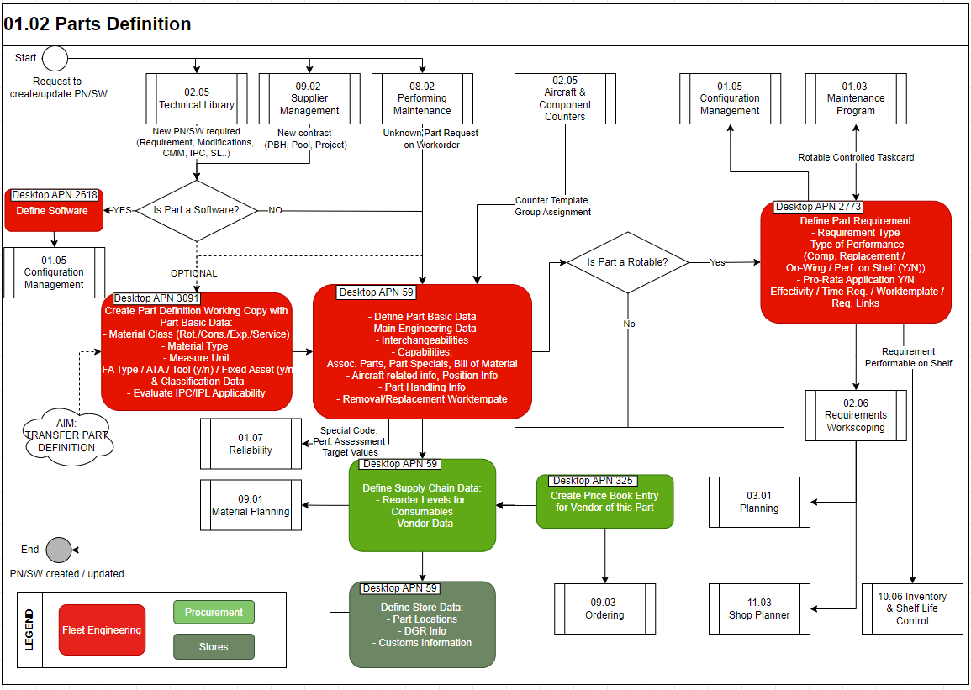

Process Design Questions

# | Question | Answer
1 | Will the ATA-200 standard be used when defining P/N?  Note: Set Parameter 1408 and use program ATA200 Part Number Checker (APN: 745).
2 | Which departments are involved in the PN creation? Who initiates the process? How would you inform the dedicated department to enter the missing data to complete the PN definition? How would you handle changes to any Partnumber information?  Note: Workflow ID-41 “New Part Entered” is helpful to communicate changes  Note: The program Technical Assistance (APN: 869) can be used to request new PNs to be created  How will the separation of duties be controlled for entering different types of data? i.e. Engineering Requirements vs. Logistics/Financial data.  Note: Workflow “Part Saving” Id-170 is helpful here to communicate different stages of the part number specification enrichment
3 | Will you use the links to IPC via the OEM Library? (OEM Documents Library - APN: 1525)  Is the OEM IPC available in SGML format?
4 | Do all your PNs have a defined average price?  Note: At Go-Live each Part Number in AMOS must have a defined Average Price.
5 | Will Tool-P/N’s be tracked in AMOS?  If yes, will the Mat. Class used for Tools only be Rotable (Serialized)? (Parameter 1137). Consumables can also be used as Tools.
6 | Which weight unit will be used as the company standard  (Configurable via Parameter 1139) (Default = Kg)
7 | Which department is responsible for adding / modifying technical parts information (e.g. effectivity, capability)?
8 | Which department is responsible for dangerous goods handling respectively for the identification of dangerous goods?
9 | You shall define an internal UNKNOWN Part Number process  Note: Technical Assistance Query (APN: 869) is highly recommended
10 | Which tracking number will be used for Repairable Consumable tags? Customized Batch Number or AMOS internal Batch Number) (Parameter 1341)

Data (Source) Mapping

Data Sources | Description | Volume / Manual / Automatic / Static / Dynamic

Other Software Used

Other Softwares | Used by: | Description
-/- | -/- | -/-

AMOS Configuration

Basic Data

Basic Data Table | Notes
Material Type
ATA-Chapter
Measure Unit
Waste Code
DGR: Class Division
DGR: Dangerous Goods Transport Regulations
DGR: Packing Instructions
DGR: UN Numbers
Time Requirement Defaults
Effectivity
Specials
Specials Contract
Requirement Type
Capability Type
Condition

Parameters

Parameter Code | Parameter name | Notes
897 | Visibility of rotable requirements and component documents in maintenance forecast
972 | Mark consumables-p/n when receiv.
1113 | Add/change vendor in read-only mode
1137 | Tool mark only for rotables
1139 | Default part weight unit
1241 | Kg use part capability list (mocl tab
1309 | Show other requirements on workorder text
1406 | External p/n tools
1408 | Deactivate ata-200 auto conversion
1431 | Partnumber searcher settings
1507 | Default part state
1508 | Public part number sequence
1519 | Part request: associated parts
1654 | Expendable part creation
1853 | ATA200 Part Number normalisation

Workflows

Workflow Number | Workflow Name | Notes
31 | Unknown Part entered in Workorder
41 | New Part Entered
47 | Part Requirement Changed
65 | Part Capability Changed
151 | Part Interchangeability De-/Activated
159 | Part Saved
169 | Part Copying
170 | Part Saving
172 | Part Synchronising
173 | Saving Bill of Material
230 | Worktemplate Modification
332 | Part is created, modified or deleted in Part Administration.
337 | Rotable is created, modified or deleted in Rotables Administration.
444 | Pending Part Definition creation / modification
531 | new Special added, modified or deleted to a component in Part Administration

Scheduled Tasks

Scheduled Task Reference | Frequency | Notes
AdjustDuplicatePartseqnoiTask
CalculateFaQtyService | Daily
FunctionalPriceInitializationTask | to be run when activating the functional average price
PartMatchDataCorrectionService | Once / on demand
PartCapabilitiesExpirationCheck | Daily
AlternateGroupsCreator | Weekly (daily in peak periods)
RequirementLinkCodePrintModeCheckTask | On Demand
UnknownPartNumberToPendingPartDefintionTask | Daily
MaterialManagementCorrectionService | Once
GenerateInventoryManagementData | Service to perform XYZ analysis for all parts on automatic or manual reorder on a daily basis.
EffectivityApplicabilityService | Each night
TimeRequirementConsistencyService | Every two days
EffectivityConsistencyTask | Once per week
PartReqTimeRequirementBaselineEventService | Once after release change / on demand

API’s & Interfaces

Reference | Direction | Trigger | Frequency
TRANSFER PART DEFINITION | Import / Export

UAT Guidance

No | Proposed User Acceptance Test scenario
1 | Create new part following a new part request on a Workorkder
2 | Create new part number due to new modification entered
3 | Setup new part interchangeability
4 | Change Material Class
5 | Change life limit time requirements time limits
6 | Upgrade Part number
7 | Set a part number inactive
8 | Create P/N with on wing requirement and its work template
9 | Set up task card link for a rotable controlled taskcard
10 | Define main store location

Annex – Additional Info

